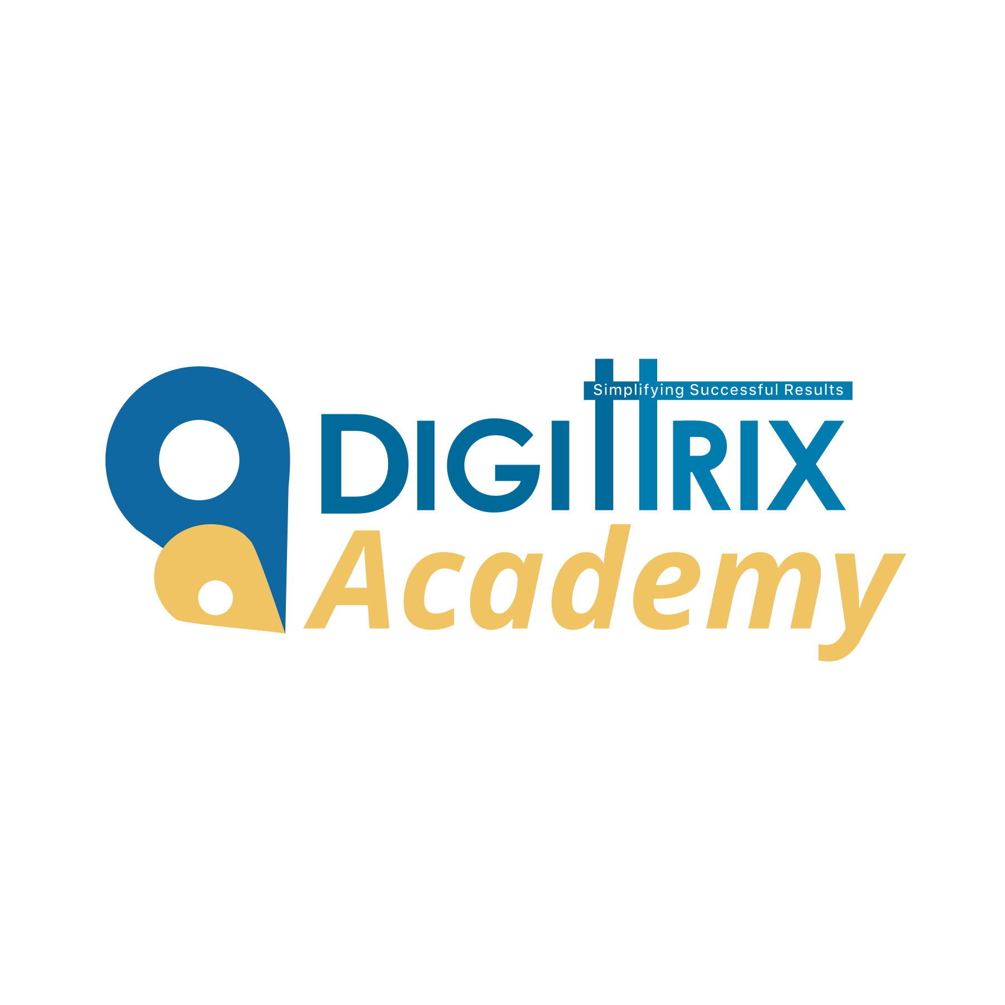

Digital Marketing Course

Duration: JOB-READY PROGRAM - 6 Months
Level : Job Ready
Best For : College students, freshers, non-technical background

A complete program to become a full-stack digital marketer, capable of handling SEO, Google Ads, Meta Ads, Social Media, Email, Analytics, Funnels, Reporting, Audits & Clients.
Highly suitable for jobs in agencies, startups, and freelancing.

⭐ Month 1 – Foundations + Social Media Essentials
Explanation:
Students build strong fundamentals and start creating social media content for real brands.
Topics:
- Digital Marketing Ecosystem (Complete Breakdown)
  - Paid vs Organic
  - Performance vs Brand marketing
  - Funnel: Awareness → Consideration → Conversion → Retention
  - Omni-channel marketing
- Social Media Platforms Overview
  - Instagram, Facebook, YouTube
  - LinkedIn basics for professionals
  - Content format types (short form, long form, reels, carousels)
- Social Media Branding + Content Strategy
  - Niche selection for brands
  - Content pillars creation
  - Writing captions that convert
  - Basic hashtag strategy
- Designing in Canva (Professional)
  - Brand kit creation
  - Carousel designs
  - Ad creatives
  - Reels cover thumbnails
- Practical Work – Month 1
  - Create 15 social media posts
  - Write captions for 10 posts
  - Create 1–2 reel scripts
  - Perform competitor analysis for 1 business

⭐ Month 2 – Social Media Advanced + Influencer Strategy
Explanation:
Students learn advanced Instagram growth and brand communication.
Topics:
- Advanced SMM
  - Trend research
  - Reel hooks formula
  - Increasing reach & engagement
  - Community building
- Brand Communication & Persona
  - Brand tone & personality
  - Emotional storytelling
  - Writing viral scripts
- Influencer Marketing Basics
  - Finding influencers
  - Costing & negotiation
  - Micro vs Macro influencer strategy
- Content Calendar Mastery
  - Building 30-day calendars
  - Scheduling using Meta Business Suite
  - KPI tracking (reach, ER, CTR)
- Practical Work – Month 2
  - Create 30-day SMM plan
  - 20+ content designs
  - 3 in-depth content breakdowns
  - Influencer plan for 1 brand

⭐ Month 3 – Google Ads + SEO Foundations
Explanation:
Students start learning the most in-demand digital marketing skills: Ads + SEO.
Topics:
- Google Ads (Search + Display)
  - Campaigns, Ad Groups, Keywords
  - Match types (Broad, Phrase, Exact)
  - Ad copywriting
  - Ad extensions
  - Negative keywords
  - Display Ads (awareness level)
  - Conversion tracking (concept)
- SEO Fundamentals Refresher
  - Keyword research
  - Title & meta creation
  - On-page optimization
  - Internal linking
  - Image SEO & alt text
- Local SEO Basics
  - Google Business Profile setup
  - NAP consistency
  - Local landing page structure
- Practical Work – Month 3
  - Create 1 Search Campaign
  - 1 Display mock campaign
  - Optimise 5 pages of a demo site

⭐ Month 4 – Meta Ads + Funnels + Landing Page Optimization
Explanation:
Students learn real performance marketing skills, funnel strategy, and landing page optimisation.
Topics:
- Meta Ads (Facebook + Instagram)
  - Campaign objectives
  - Targeting strategies
  - Retargeting basics
  - Lookalike audiences
  - Budget optimization
- Landing Page Optimization (CRO Fundamentals)
  - Hero section formula
  - Writing converting copy
  - CTA placement
  - Trust signals
  - UX-based improvements
- Funnels (Lead Generation + E-Commerce)
  - Cold → Warm → Hot audience flow
  - Lead magnet ideas
  - Building mini funnels
  - Retention basics
- Practical Work – Month 4
  - Create 1 Meta Ads campaign outline
  - Build a landing page wireframe
  - Funnel structure for a client niche

⭐ Month 5 – Analytics, Reporting, Automation + Real Projects
Explanation:
This month focuses on the skills that companies demand the most: Analytics + Reports + Tools.
Topics:
- Analytics (GA4 + Insights)
  - Traffic analysis
  - Engagement metrics
  - Attribution basics
  - Google Search Console usage
  - UTM tracking
- Marketing Automation (Beginner)
  - Email sequences (welcome flow, lead nurturing)
  - Drip campaigns (overview)
  - Tools: Mailchimp, Sender, Zoho (overview)
- Reports Preparation (Client-Level)
  - SEO monthly report
  - SMM monthly report
  - Ads monthly report
  - ROI/ROAS basics
- Real Client/Project Work
  - Managing a demo brand’s digital presence
  - Weekly execution (posting + ads + SEO tasks)
  - Competitor tracking
- Practical Work – Month 5
  - Prepare a full 1-month digital marketing report
  - Do an audit of 1 business (SEO + SMM + Ads)
  - Create dashboards in Google Sheets

⭐ Month 6 – Freelancing, Interviews & Job Placement
Explanation:
The final month prepares students to start a career confidently: job roles, freelancing, interviews, portfolio building.
Topics:
- Freelancing (Fiverr + Upwork)
  - Creating profiles
  - Building DM gigs
  - Pricing strategy
  - Closing clients
  - Delivering DM work
- Portfolio Building
  - Turning projects into case studies
  - Organising SEO/SMM/Ads work
  - Creating a digital portfolio (Google Drive / Canva PDF / Notion)
- Resume + LinkedIn Optimization
  - Writing a job-ready resume
  - About section
  - DM keywords for recruiters
- Interview Preparation
  - Top 40+ DM interview questions
  - Practical scenario questions
  - How to explain your projects
- Placement Support
  - Applying to 30–50 companies
  - HR connections
  - Mock interviews
  - Guidance for assignments
- Practical Work – Month 6
  - Build a complete DM portfolio
  - Create 1–2 real DM case studies
  - Apply for 20+ jobs with faculty guidance

⭐ Outcome After 6 Months
By the end of this course, students can:
- Manage complete digital marketing projects
- Run Facebook/Instagram & Google Ads
- Handle SEO & content
- Create reports, dashboards, and strategies
- Build landing pages
- Work with real clients
- Apply for Digital Marketing Executive / Social Media Manager / Ads Specialist jobs
- Start freelancing

⭐ Why It’s Popular
- Demand is extremely high in Mohali/Chandigarh (Digital Agencies belt)
- Easiest IT domain for NON-technical students
- Freelancing & YouTube/Blogging opportunities

🧠 Skills You Learn
- On-Page SEO (content optimization)
- Off-Page SEO (backlinks)
- Technical SEO (sitemaps, robots, schema)
- Google Analytics & Search Console
- Local SEO (Google My Business)
- Tools: Ahrefs, SEMrush, MOZ

💼 Job Roles
- Digital Marketing Executive
- Social Media Manager
- Google Ads Executive
- SEO Executive
- Performance Marketing Intern
- Content Marketer

💼 Freshers’ Salary Range
₹12,000 – ₹15,000/month

🤝 Our Partners
